SHIRE OF HALLS CREEK
Public Notice
The Shire is calling for suitably qualified local persons to join a Signage Working Group for the development of content for the Halls Creek Township. The Signage will include interpretive stories relating to culture, history and the development of Halls Creek and surrounds. It is intended that the Working Group will be required for approximately one year and meet monthly. A sitting fee of $200 per person per meeting will be made available to approved Working Group members.
Please submit Expressions of Interest to hcshire@hcshire.wa.gov.au by 4pm 31st March 2023 with a brief summary of your suitability for this role.

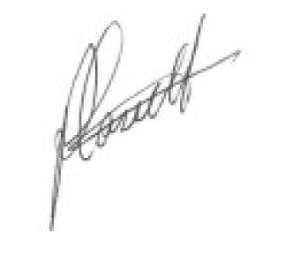
Phillip Cassell
Chief Executive Officer

