Bushfire Risk Management Statement – 31 and 59 Welman Road, Halls Creek
Background
Under the State Hazard Plan Fire an integrated Bushfire Risk Management (BRM) Plan is to be developed for local government areas with significant bushfire risk. The Shire of Halls Creek has not yet prepared a district wide BRM plan.
The Shire of Halls Creek has made an application to re-zone Lot 258, 31 Welman Road and Lot 315, 59 Welman Road, DP213320, from Residential R20 to Residential R40. The purpose of the proposed rezoning being to provide grouped accommodation for Shire staff. The two lots are in bushfire prone areas according to the Bushfire Prone Areas Map of Western Australia.

Aim and Objectives
The aim of the BRM Plan is to effectively manage bushfire risk in order to protect people, assets and other things of local value. The objectives of this BRM Plan are to;
- Identify, analyse and evaluate risk , determine priority actions to systematically treat risk at 31 and 59 Welman Road
- Monitor and review the implementation of treatment plans to ensure they are an integral part of development approval at the development stage.
Legislation and Policy Standards
- Bush Fires Act 1954
- Bush Fire Regulations 1954
- Emergency Management Act 1986
- Planning and Development (Local Planning Schemes) Regulations 2015
- State Hazard Plan Fire (SEMC 2019)
- State Planning Policy 3.7 – Planning in Bushfire Prone Areas (WAPC 2015, as amended)
- AS3959:2009 Construction of Buildings in Bushfire-Prone Areas
Description of the subject sites
Lot 258 (31 Welman Road) and Lot 315 (59 Welman Road) are both located at the ‘Garden Area’ residential subdivision, with lot 258 partly being in a bushfire prone area an Lot 315 being in the bushfire prone area according to the Bushfire Prone Areas Map of Western Australia.
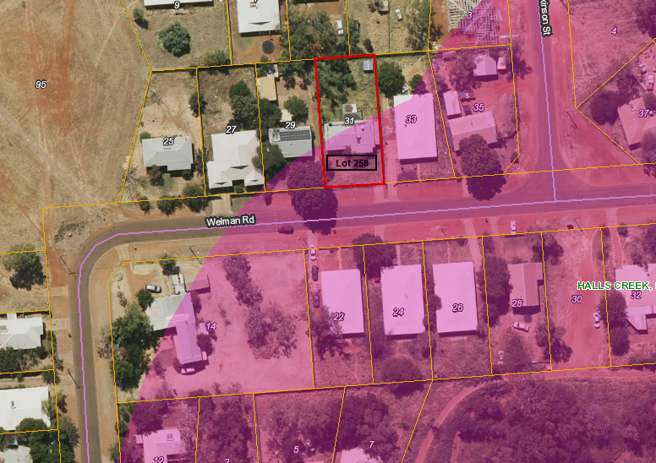
Figure 1 Lot 258 - Partially in the bushfire prone area, with Welman Road and residences across the road as Buffer

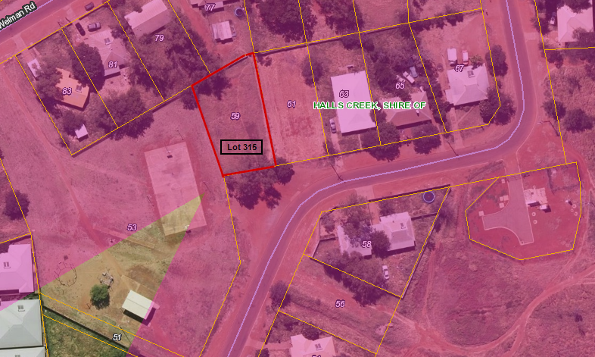
Figure 2 Lot 315-Bushfire prone, with Welman Road and residences across as buffer

The two lots are in a built-up residential area and none have a boundary at the periphery of the residential subdivision.
Bushfire Protection
To prevent accidental bushfires from affecting residences in this subdivision,
- The Shire cuts a firebreak around the subdivision every year at the end of the wet season.
- The Shire uses rear mount tractor mowers to reduce fuel and create a protection zone around the residences.
- Backburning is periodically undertaken, especially after the wet season.
- Should the line of residences at the periphery of the building be impacted, Welman Road also acts as a firebreak for these two lots.
Bushfire Management Plan
A Bushfire Management Plan must be prepared and submitted with applications for development approval. The Bushfire Management Plan will be referred to DFES for approval, before processing of development planning applications, pursuant to State Planning Policy 3.7.

