Position type | Full Time
Position classification | Local Government Officers (WA) Award
Remuneration level | Level 3
Primary work location | Halls Creek
Reports to | Director Community Development
Department | Community Development
Date last reviewed | June 2026

About the Shire of Halls Creek
Located in the Kimberley region of Western Australia, the Shire of Halls Creek (Shire) is one of Australia’s iconic outback areas with a unique cultural and heritage environment.
The Shire covers 142,908 square kilometres of the Kimberley and is approximately 2,850 kilometres to the north east of Perth and 362 kilometres south of Kununurra. The Northern Territory forms the eastern boundary of the Shire with the Shire of Wyndham-East Kimberley to the north, the Shire of Derby-West Kimberley to the west and the Shire of East Pilbara to the south and west.
The remote communities of Balgo (Wirrimanu), Billiluna (Mindibungu), Mulan, Ringer Soak (Kundat Djaru), Warmun (Turkey Creek) and Yiyili are an integral part of the Shire with around 3,000 people residing outside of the Halls Creek town site. Throughout the Shire there are also a number of smaller communities.
The Shire is connected by 391 kilometres of sealed roads and 1,449 kilometres of unsealed roads requiring extensive maintenance work due to seasonal flooding.

Our operating environment
The Shire operates within a broad legislative framework that includes but is not limited to:
- Disability Services Act 1993 (WA)
- Fair Trading Act 2010 (WA)
- Fair Work Act 2009 (Cth) and Fair Work Regulations 2009
- Financial Management Act 2006
- Income Tax Assessment Act 1936 (Cth) (as amended)
- Income Tax Assessment Act 1997 (Cth) (as amended)
- Work Health and Safety Act 2020
- Privacy Act 1988 (Cth)
- State Records Act 2000 (WA)
- Superannuation Guarantee (Administration) Act 1992 (Cth)
The Shire is enabled by the Local Government Act 1995 and its regulations. It operates under two industrial awards being Local Government Officers (Western Australia) Award and the Municipal Employees (Western Australia) Award.

Our vision and goals
Our 2015-2025 strategic community plan outlines a clear vision for the Shire to be economically diverse, caring and proactive with a strong sense of responsibility and pride. This vision will be realised through four strategic goals: Local Jobs, Local Economy, Local Social and Local Leadership.

Our values
As one of the biggest employers in the Shire, our goal is to be a great place to work where everyone matters and there are opportunities to grow. We have a strong commitment to
well-being, health and safety, diversity and inclusion. Everything Council does is underpinned by our values, which define the culture of the organisation and the behaviours that shape our interaction with the community and each other. Our values are depicted below and they are embedded in everyone’s roles.

Community aspirations
Through consultations with community on development of the 2015-2025 strategic community plan, the following community aspirations were identified. We strive to work with the community to realise these aspirations.
Aspiration | Benefits
Community involvement | Values the contributions of all groups and ages and generates opportunities for active participation
Respect for, and engagement with the traditional owners of the land. | Ensuring pace and level of development impacting Indigenous communities is guided by the Traditional Owners.
Social inclusiveness | Promotes a future for all residents, actively strengthens the social fabric of the community, values diversity and responds to special needs and disadvantage.
Positive Mindset | Fosters community attitudes that embrace change, proactive ‘can do’ behaviours, optimism, hopefulness and the belief in the community being architects and builders of their social and economic future.
Access and Equity | Provides all residents with adequate health, educational, learning, housing and recreational opportunities, facilities and programs.
Celebration | Encourages pride and times of celebration relating to the town’s heritage, uniqueness, cultures and achievements.

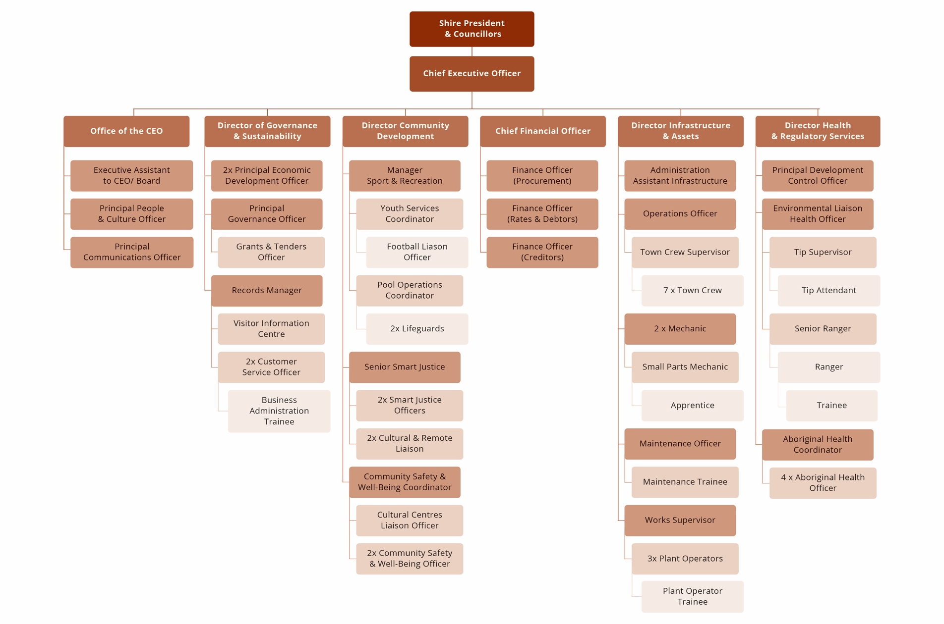
Our structure

Your role

The Security Officer is responsible for providing a visible, professional and community-focused security presence across Shire facilities, public spaces and the broader Halls Creek town site. This frontline role covers the full scope of security operations including the protection and monitoring of Shire assets and facilities, proactive town patrol and community safety, and the delivery of security services at Shire-run events and community gatherings. Operating in a unique remote and culturally diverse environment, the Security Officer is expected to engage respectfully and sensitively with Aboriginal and Torres Strait Islander community members while upholding the safety and wellbeing of all residents, visitors and staff.

Key responsibilities
Activities | Responsibilities
Plan | Facilities & Public Spaces  - Review daily security schedules, patrol routes and facility access requirements at the commencement of each shift  - Conduct pre-shift briefings and assess known risks, recent incidents or areas of concern prior to commencing patrols  - Identify and plan responses to security risks, access vulnerabilities and potential hazards across Shire facilities and public spaces  Town Patrol & Community Safety  - Plan patrol routes and schedules to maximise visibility and coverage across the Halls Creek town site  - Liaise with supervisors and relevant agencies to coordinate responses to known community safety concerns or emerging risks  Events & Crowd Management  - Assist with the development of security and crowd management plans for Shire events and community gatherings  - Review event schedules, venue layouts and expected attendance to identify security risks and resource requirements prior to events
Develop & Implement | Facilities & Public Spaces  - Conduct regular patrols of Shire facilities, buildings, car parks, open spaces and public amenities to deter and detect unauthorised activity, vandalism and anti-social behaviour.  - Monitor and manage access to Shire facilities, including opening and securing buildings, checking locks, alarms and CCTV systems.  - Respond promptly and appropriately to security breaches, trespassing, property damage and other incidents in accordance with Shire procedures and relevant legislation.  - Liaise with WA Police and other emergency services as required in response to incidents.  - Undertake minor emergency response duties including first aid, fire safety checks and evacuation support as required.  Town Patrol & Community Safety  - Engage respectfully and proactively with community members, including Aboriginal and Torres Strait Islander residents, to support community safety and de-escalate situations before they escalate.  - Monitor and respond to anti-social behaviour, public disturbances and welfare concerns in the community in a calm, culturally sensitive and legally appropriate manner.  - Refer individuals to appropriate support services where welfare, intoxication or family safety concerns are identified.  Events & Crowd Management  - Provide security services at Shire-run events, community gatherings, sporting events and activations, including access control, crowd monitoring and incident response.  - Implement crowd management plans, manage entry and exit points, and ensure patron safety throughout events.  - Identify and respond to disruptive behaviour, intoxication or safety concerns at events in a firm, fair and respectful manner.  - Coordinate with event organisers and other staff to ensure smooth and safe event operations.  - Conduct post-event security checks and secure venues following the conclusion of events.
Evaluate, Report & Record | - Complete accurate and timely shift logs, patrol reports and incident reports for all security activities, observations and incidents  - Record and report damage, vandalism, maintenance issues or safety hazards identified during patrols to the relevant supervisor  - Document all community welfare referrals, incident responses and interactions with WA Police or emergency services  - Participate in post-incident debriefs and contribute to the review and improvement of security procedures  - Maintain up-to-date records of mandatory qualifications, licences and training certifications
Promote | - Promote a visible, professional and reassuring security presence that builds community confidence and trust.  - Represent the Shire of Halls Creek professionally and positively at all times when interacting with community members, stakeholders and partner agencies.
Advise & Advocate | - Identify and report facility vulnerabilities, maintenance needs and infrastructure issues that may present security or safety risks.  - Advocate for a community-centred approach to security that prioritises de-escalation, cultural sensitivity and connection to support services over enforcement alone.  - Contribute to the review and improvement of security procedures, patrol strategies and event management plans.  - Raise awareness of patterns of anti-social behaviour, emerging risks or community safety issues to inform Shire planning and responses.

Mandatory requirements
Experience | - Experience working in a security, community safety, law enforcement or related field  - Demonstrated experience engaging with members of the public in a professional, calm and respectful manner, including in challenging or high-pressure situations  - Experience working with Aboriginal and Torres Strait Islander communities in a culturally appropriate and respectful manner  - Experience conducting patrols, monitoring facilities or managing access control  - Experience providing security at events or public gatherings (desirable)  - Experience working in a remote or regional community environment (desirable)
Skills | - Strong interpersonal and communication skills, with the ability to de-escalate conflict and engage respectfully with diverse community members  - Ability to remain calm, professional and composed in challenging, confrontational or emergency situations  - Sound observation and situational awareness skills, with the ability to identify and respond to security risks  - Reliable, punctual and able to follow procedures, instructions and legislation accurately  - Basic computer literacy for shift logging, incident reporting and record keeping  - Ability to work independently, exercise sound judgement and make decisions in a remote and complex environment  - Physical fitness to conduct foot and vehicle patrols and respond effectively in emergency situations
Knowledge | - Knowledge of security operations, patrol procedures and access control principles.  - Understanding of relevant legislation governing security operations in Western Australia, including the Security and Related Activities (Control) Act 1996  - Awareness of community safety issues facing remote and Aboriginal communities in the Kimberley region  - Knowledge of de-escalation techniques and trauma-informed approaches to community engagement  - Understanding of WHS obligations, duty of care and use-of-force limitations applicable to security personnel  - Desirable: Knowledge of local government operations and the role of community safety within a Shire context
Qualifications | - Current Certificate II in Security Operations (CPP20218) or equivalent – required.  - Current WA Security Licence (issued by WA Police) – required.  - Provide First Aid (HLTAID011).  - Current CPR (HLTAID009, renewed annually).  - Working with Children Check (WWCC).  - Current C Class Driver’s Licence.  - Desirable: Certificate III in Security Operations or higher.  - Desirable: Crowd Controller Licence (WA).  - Desirable: Mental Health First Aid Certificate
Licenses | - Current WA Security Licence is mandatory.  - Current C Class Driver’s Licence is mandatory  - Proof of licences will be required prior to appointment. If your licences are not from an Australian educational institution you may need to get formal recognition of equivalency prior to applying
Pre-employment Medical & Drug Test | It is a requirement for all employees of the Shire of Halls Creek to undertake a medical with necessary testing suitable for the role, duties and obligations of the position, which will include a drug test.
National Criminal Clearance | It is a requirement for all employees of the Shire of Halls Creek to provide a National Police Clearance and maintain a clear record as it pertains to the requirements of the role, duties and obligations of the position.
Working with Children Clearance | This position requires the employee to hold, and maintain during employment, a valid Working with Children Check (WWCC) or equivalent clearance as required under the relevant state or territory legislation. The successful applicant must:  - provide evidence of a current WWCC prior to commencement or provide a valid application receipt of lodgement of WWCC  - maintain the clearance for the duration of their employment  - immediately notify the Shire if the clearance is suspended, cancelled, or subject to review.
Compliance Obligations | All employees of the Shire are required to comply with statutory, regulatory and organisational obligations, including but not limited to:  - comply with all Work Health and Safety legislation, regulations, codes of practice, and the Shire’s WHS policies and procedures.  - participate in safety training, consultation, and risk management processes.  - use personal protective equipment (PPE) and safety equipment as required.  - carry out duties in compliance with the Local Government Act 1995, associated regulations, and Council policies.  - comply with all relevant legislation, awards, industrial instruments, policies, and procedures applicable to the role.

Corporate requirements
- Commit to the agreed Shire of Halls Creek values and behaviours
- Comply with the Shire of Halls Creek Code of Conduct
- Participate in staff performance and career development program
- Commit to the wellbeing, health and safety of everyone

Authorisation
The details contained in this document are an accurate statement of the purpose, duties and role specifications and other requirements of the position.

Susan Leonard
Chief Executive Officer Date……………………………………..

I have read, understood, and agree to the requirements and responsibilities outlined in this Position Description.

Signed…………………………………..…………… Date……………………………………..
Employee

