Position type | Full time
Position classification | Executive
Remuneration level | Negotiable
Primary work location | Halls Creek
Reports to | Chief Executive Officer
Department | Health and Regulatory
Date last reviewed | 31 December 2025

About the Shire of Halls Creek
Located in the Kimberley region of Western Australia, the Shire of Halls Creek (Shire) is one of Australia’s iconic outback areas with a unique cultural and heritage environment.
The Shire covers 142,908 square kilometres of the Kimberley and is approximately 2,850 kilometres to the north east of Perth and 362 kilometres south of Kununurra. The Northern Territory forms the eastern boundary of the Shire with the Shire of Wyndham-East Kimberley to the north, the Shire of Derby-West Kimberley to the west and the Shire of East Pilbara to the south and west.
The remote communities of Balgo (Wirrimanu), Billiluna (Mindibungu), Mulan, Ringer Soak (Kundat Djaru), Warmun (Turkey Creek) and Yiyili are an integral part of the Shire with around 3,000 people residing outside of the Halls Creek town site. Throughout the Shire there are also a number of smaller communities.
The Shire is connected by 391 kilometres of sealed roads and 1,449 kilometres of unsealed roads requiring extensive maintenance work due to seasonal flooding.

Our operating environment
The Shire operates within a broad legislative framework that includes but is not limited to:
- Disability Services Act 1993 (WA)
- Fair Trading Act 2010 (WA)
- Fair Work Act 2009 (Cth) and Fair Work Regulations 2009
- Financial Management Act 2006
- Income Tax Assessment Act 1936 (Cth) (as amended)
- Income Tax Assessment Act 1997 (Cth) (as amended)
- Work Health and Safety Act 2020
- Privacy Act 1988 (Cth)
- State Records Act 2000 (WA)
- Superannuation Guarantee (Administration) Act 1992 (Cth)
The Shire is enabled by the Local Government Act 1995 and its regulations. It operates under two industrial awards being Local Government Officers (Western Australia) Award and the Municipal Employees (Western Australia) Award.

Our vision and goals
Our 2015-2025 strategic community plan outlines a clear vision for the Shire to be economically diverse, caring and proactive with a strong sense of responsibility and pride. This vision will be realised through four strategic goals: Local Jobs, Local Economy, Local Social and Local Leadership.

Our values
As one of the biggest employers in the Shire, our goal is to be a great place to work where everyone matters and there are opportunities to grow. We have a strong commitment to
well-being, health and safety, diversity and inclusion. Everything Council does is underpinned by our values, which define the culture of the organisation and the behaviours that shape our interaction with the community and each other. Our values are depicted below and they are embedded in everyone’s roles .

Community aspirations
Through consultations with community on development of the 2015-2025 strategic community plan, the following community aspirations were identified. We strive to work with the community to realise these aspirations.
Aspiration | Benefits
Community involvement | Values the contributions of all groups and ages and generates opportunities for active participation by residents in planning and action.
Respect for, and engagement with the traditional owners of the land. | Ensuring pace and level of development impacting Indigenous communities is guided by the Traditional Owners.
Social inclusiveness | Promotes a future for all residents, actively strengthens the social fabric of the community, values diversity and responds to special needs and disadvantage.
Positive Mindset | Fosters community attitudes that embrace change, proactive ‘can do’ behaviours, optimism, hopefulness and the belief in the community being architects and builders of their social and economic future.
Access and Equity | Provides all residents with adequate health, educational, learning, housing and recreational opportunities, facilities and programs.
Celebration | Encourages pride and times of celebration relating to the town’s heritage, uniqueness, cultures and achievements.

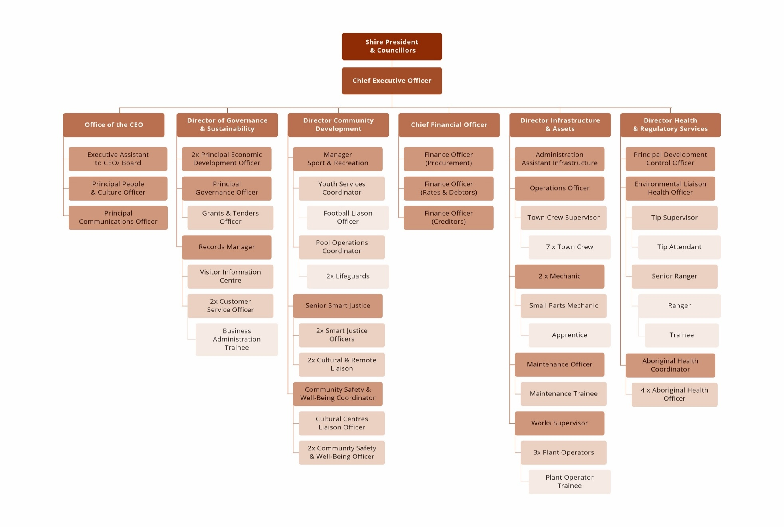
Our structure

Your role
The Director Health and Regulatory Services provides strategic leadership, direction, and oversight of the Shire’s regulatory and compliance functions, including Environmental Health, Building Services, Ranger Services, Emergency Management and Waste Management.
This role ensures the effective implementation of public health and safety standards, community compliance with statutory requirements, and delivery of essential environmental and regulatory programs. The position contributes to the Shire’s strategic vision by supporting sustainable development, protecting community wellbeing, and ensuring a safe and healthy living environment across the district.
Activities | Responsibilities
Plan | - Provide strategic leadership and foster the effective management of the Health and Regulatory Service functions within the Department.  - Develop and implement the Health and Regulatory Services operational plan in alignment with the Shire’s Strategic Community Plan and Corporate Business Plan.  - Lead the development and review of planning policies, environmental health policies, building control procedures, and ranger service programs.  - Identify community health and safety priorities and develop strategies to address emerging issues.  - Oversee budget preparation, financial planning, and resource allocation for all sections within the Directorate.
Develop & Implement | - Manage the delivery of high-quality environmental health services, including food safety, water quality monitoring, waste management, and public health compliance.  - Ensure effective administration of the Public Health Act 2016 (WA), Health (Miscellaneous Provisions) Act 1911, Local Government Act 1995, and related legislation.  - Oversee statutory planning development approvals, review of the Local Planning Scheme and compliance with the Planning and Development Act and Regulations.  - Oversee building approvals, inspections, and compliance with the Building Act 2011 and Building Code of Australia.  - Lead the Ranger Services team in enforcing local laws, animal control, parking, and community safety regulations.  - Oversee the management of the cemetery and efficient processing of burial applications.  - Coordinate emergency management planning, preparedness, and response in collaboration with relevant agencies.  - Ensure waste facilities and landfill operations meet environmental and licensing requirements.  - Develop community education programs promoting health, safety, and responsible community behaviour.
Evaluate, Report & Record | - Monitor and report on service delivery performance, compliance levels, and regulatory enforcement outcomes.  - Prepare regular reports and recommendations to the CEO and Council.  - Ensure accurate records are maintained in accordance with statutory obligations and the Shire’s recordkeeping systems.
Promote | - Lead Council’s strategic advocacy to government and other external stakeholders on matters related Health and Regulatory and Council priorities.  - Build and maintain professional relationships based on mutual trust, respect, transparency and understanding.  - Enhance the reputation of the Shire as a destination through innovation, thoughtful design, collaboration and partnerships  - Provide competent strategic advice to the CEO and Council and lead integrated policy development, along with expert and informed analysis on Health and Regulatory functions including compliance with legislation.
Advise & Advocate | - Provide expert advice to the CEO, Council, and community on health and regulatory issues.  - Interpret and apply relevant legislation, regulations, and policy frameworks to guide operational decisions.  - Advocate for community health and environmental sustainability outcomes through collaboration with government and industry partners.

Mandatory requirements
Demonstrated Experience | - Relevant tertiary qualification in Environmental Health, Public Health, Environmental Science, or a related discipline.  - Extensive experience in managing health, regulatory, or compliance functions within local government or a similar environment.  - Demonstrated understanding of public health legislation, environmental management, and building compliance frameworks.  - Strong leadership and team management skills with the ability to inspire and develop multidisciplinary teams.  - Excellent analytical, problem-solving, and decision-making skills.  - Proven ability to manage budgets, strategic projects, and regulatory reporting requirements.  - High-level written and verbal communication skills, with the ability to prepare clear reports and correspondence.  - Strong stakeholder engagement and negotiation abilities.
Skills | - High-level verbal, written, and negotiation skills.  - Ability to write successful funding applications, manage projects, and meet reporting requirements.
Role Specific Requirements | - Extensive skills in procurement and contract management  - Knowledge of environmental sustainability, waste management, and land-use planning principle.  - Experience in emergency management and local law enforcement.  - Sound understanding of governance, risk management, and legislative compliance.
Qualifications | Proof of qualifications and registrations will be required prior to appointment. If your qualification/s are not from an Australian educational institution you may need to get formal recognition of equivalency prior to applying.
Licenses | Proof of licences will be required prior to appointment. If your licences are not from an Australian educational institution you may need to get formal recognition of equivalency prior to applying.
Pre-employment Medical & Drug Test | It is a requirement for all employees of the Shire of Halls Creek to undertake a medical with necessary testing suitable for the role, duties and obligations of the position, which will include a drug test.  It is a requirement of this role that psychometric testing be undertaken.
National Criminal Clearance | It is a requirement for all employees of the Shire of Halls Creek to provide a National Police Clearance and maintain a clear record as it pertains to the requirements of the role, duties and obligations of the position.
Working with Children Clearance | This position does not require the employee to hold, and maintain during employment, a valid Working with Children Check (WWCC) or equivalent clearance as required under the relevant state or territory legislation. The successful applicant must:  - provide evidence of a current WWCC prior to commencement or provide a valid application receipt of lodgement of WWCC  - maintain the clearance for the duration of their employment  - immediately notify the Shire if the clearance is suspended, cancelled, or subject to review.
Compliance Obligations | All employees of the Shire are required to comply with statutory, regulatory and organisational obligations, including but not limited to:  - comply with all Work Health and Safety legislation, regulations, codes of practice, and the Shire’s WHS policies and procedures.  - participate in safety training, consultation, and risk management processes.  - use personal protective equipment (PPE) and safety equipment as required.  - carry out duties in compliance with the Local Government Act 1995, associated regulations, and Council policies.  - comply with all relevant legislation, awards, industrial instruments, policies, and procedures applicable to the role.

Corporate requirements
- Comply with the Shire of Halls Creek Code of Conduct
- Commit to equity, diversity, and inclusion, with cultural awareness and respect for Aboriginal heritage and community priorities
- Participate in staff performance and career development program
- Commit to the wellbeing, health and safety of everyone

Tools of Trade

Mobile Phone Desktop Executive Laptop

Tablet Staff Housing Vehicle - Business use only

Vehicle - Personal Use - Kimberley only
Maximum fuel allowance of $7000 per annum (inclusive of GST)

Authorisation
The details contained in this document are an accurate statement of the purpose, duties and role specifications and other requirements of the position.

Date:

Susan Leonard
Chief Executive Officer

I have read, understood, and agree to the requirements and responsibilities outlined in this Position Description.

Signed…………………………………..…………… Date……………………………………..
Employee

