New Bin and Parts Order form
NAME:

ADDRESS:

MOBILE:

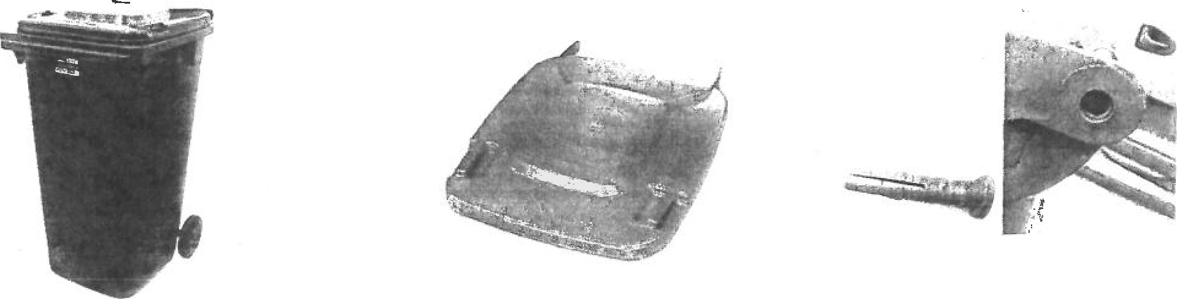
New Bin $162 New Lid $33 Hinge Pins $3.50

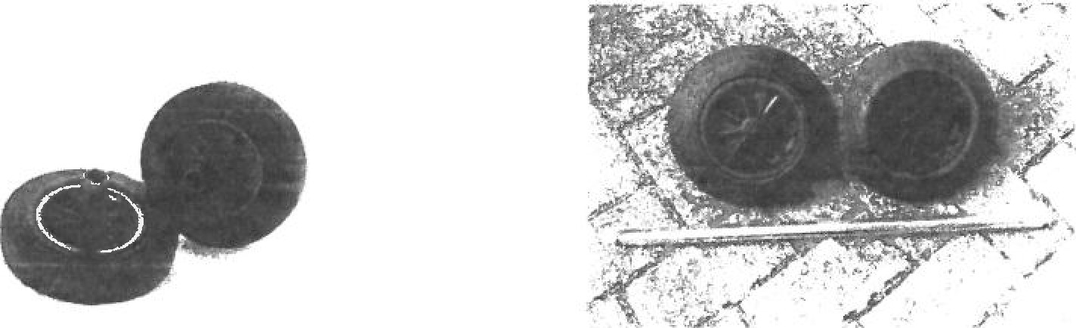
Wheels $15.75 Axel $15.75

NAME:

ADDRESS:

AMOUNT PAID: SIGN:

