

**New Bin and Parts Order Form**

Name: __________________________________________________________________________

Address: _________________________________________________________________________

________________________________________________________________________________

________________________________________________________________________________

Mobile: _________________________________________________________________________

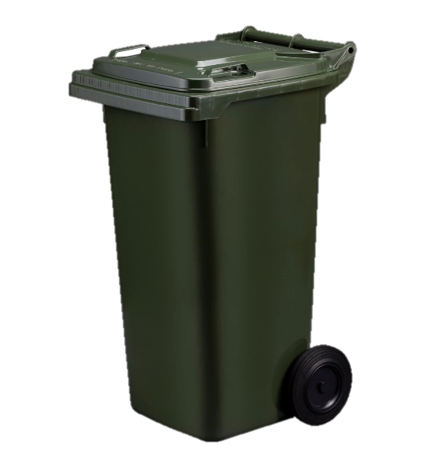

**New Bin - $162**

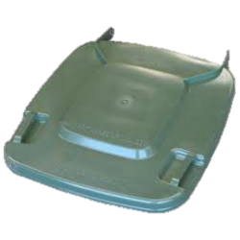

**New Lid - $33**

**New Axel - $15.75**

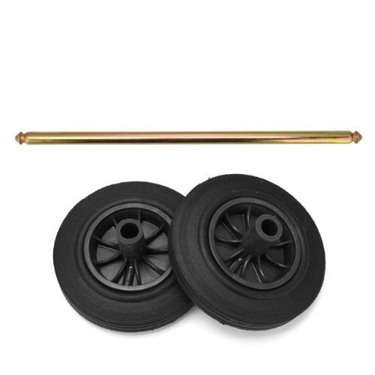

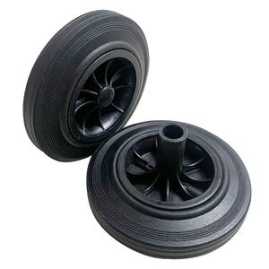

**New Hinge Pins - $3.50**

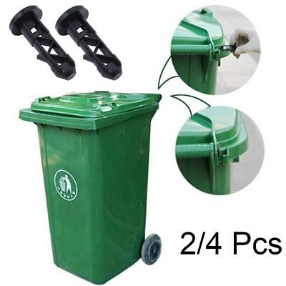

**New Wheels - $15.75**

Name of Property Owner: ___________________________________________________________

________________________________________________________________________________

Address: _________________________________________________________________________

________________________________________________________________________________

Amount Paid: _________________ Signature: _______________________